1. Search option not display in Product Cat dropdown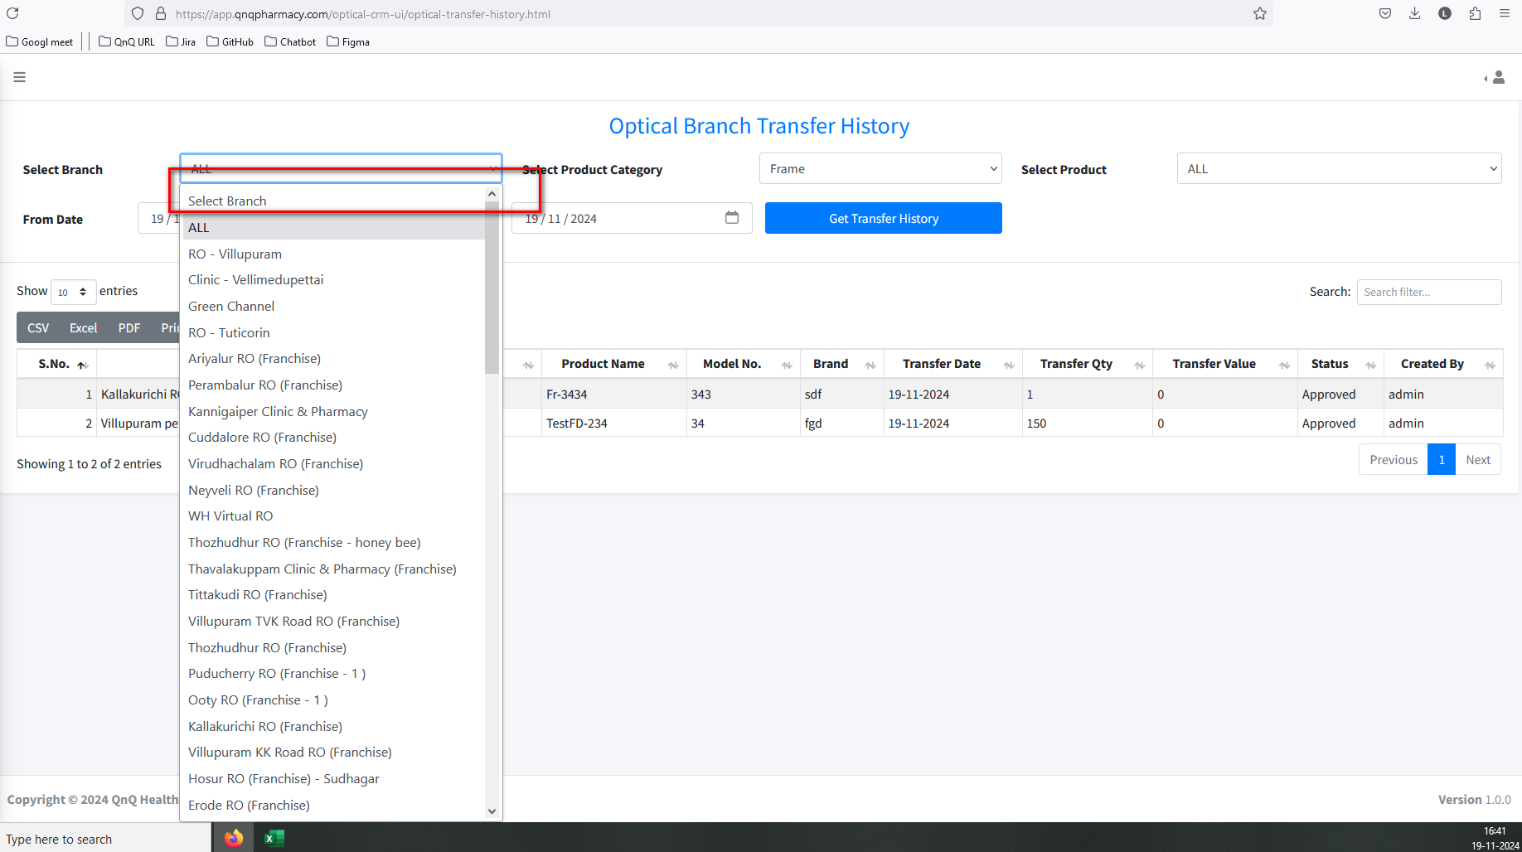//
2. Unwanted pop-up display while select all value in Product Category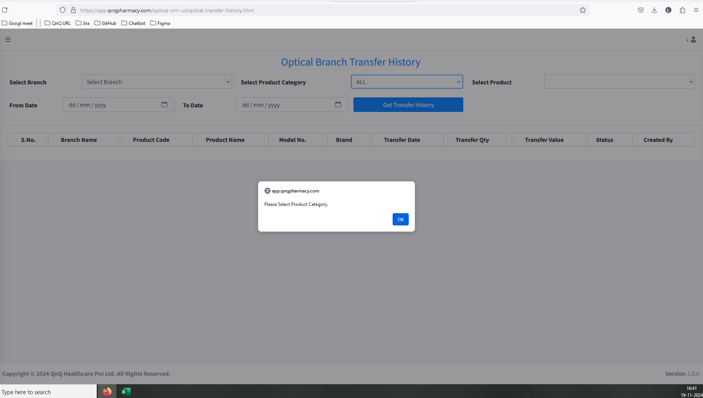//
3. Product field not display any value when Product Category value has selected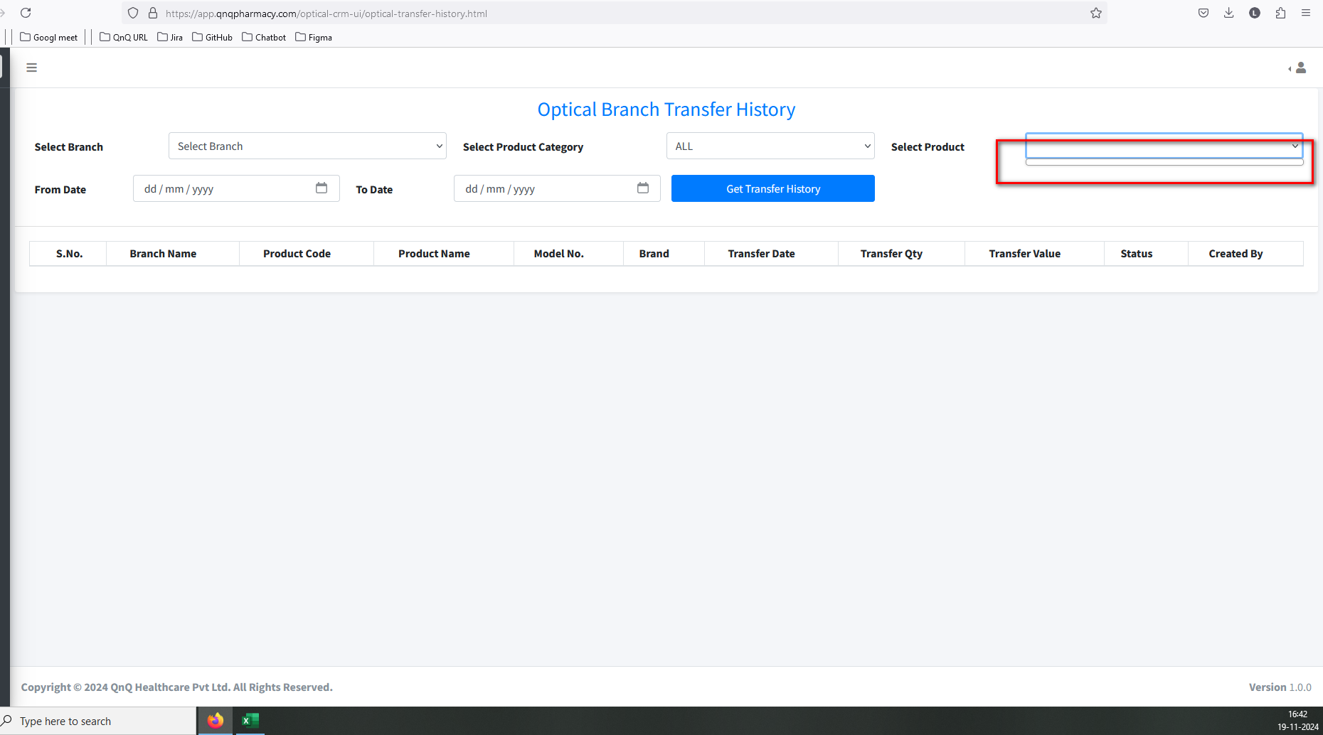//
4. No data message not display in dropdown//
5. Refresh icon not available to clear the search filter values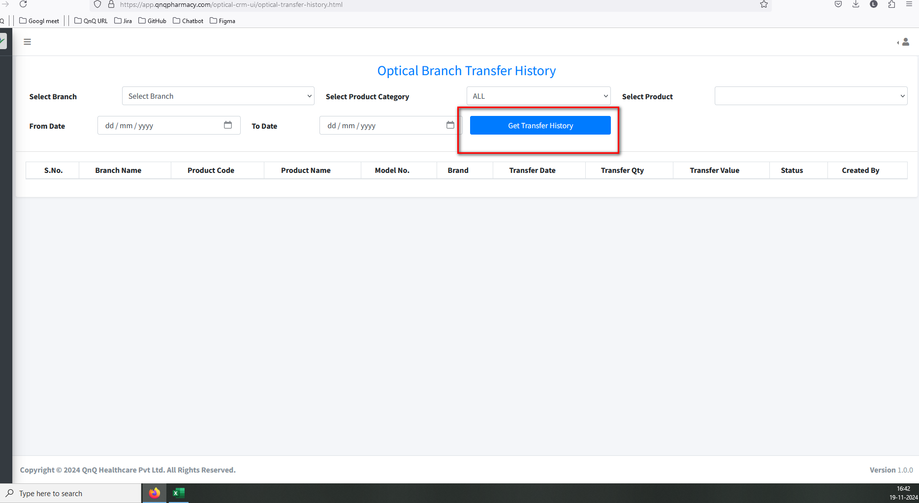//
6. Unwanted error message display while open the CSV file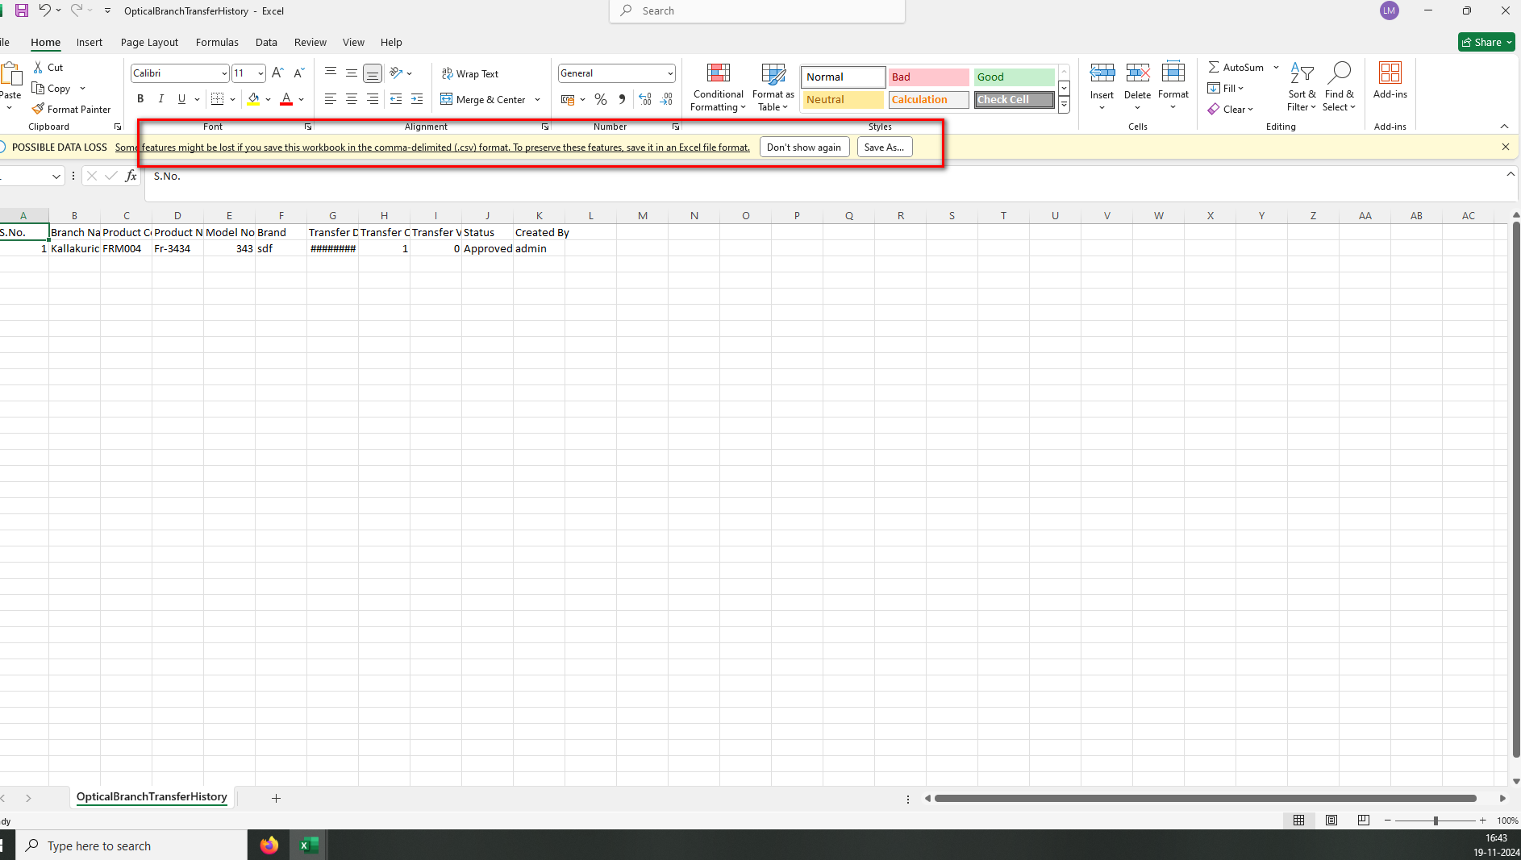 //
7. The column header does not appear like the ad header column in CSV file 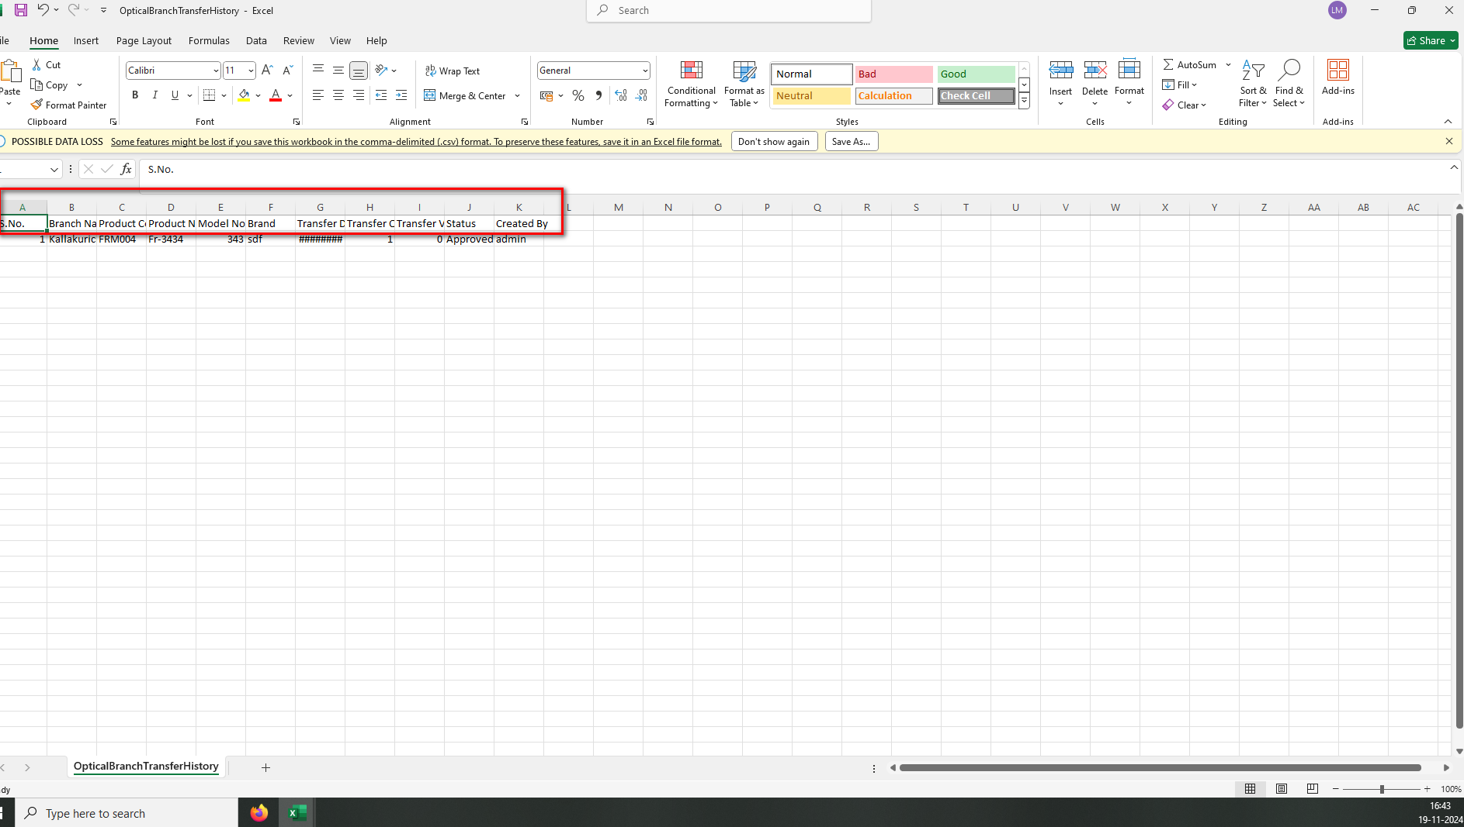//
8. Hash value display while open the downloaded CSV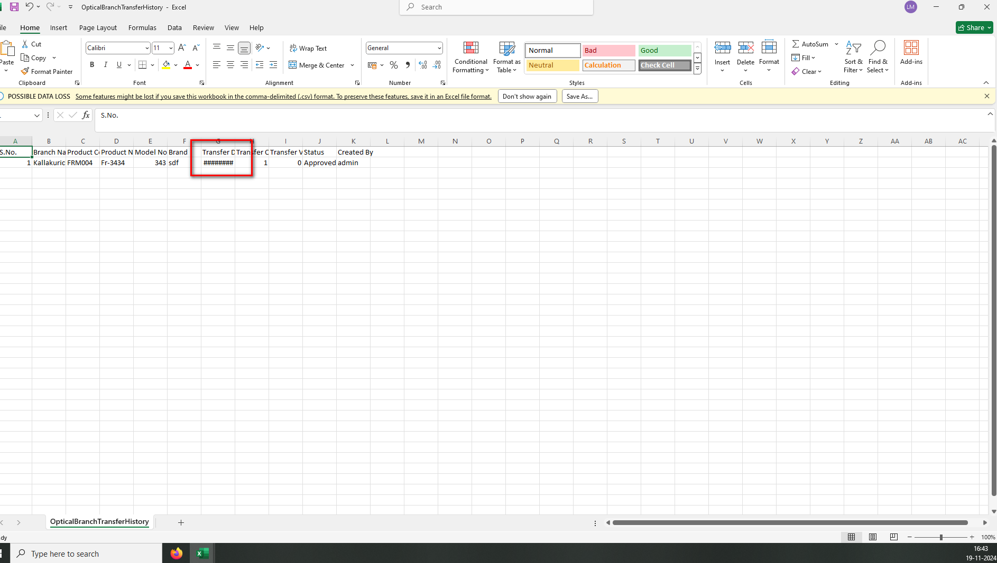//
9. Improper alignment display in list grid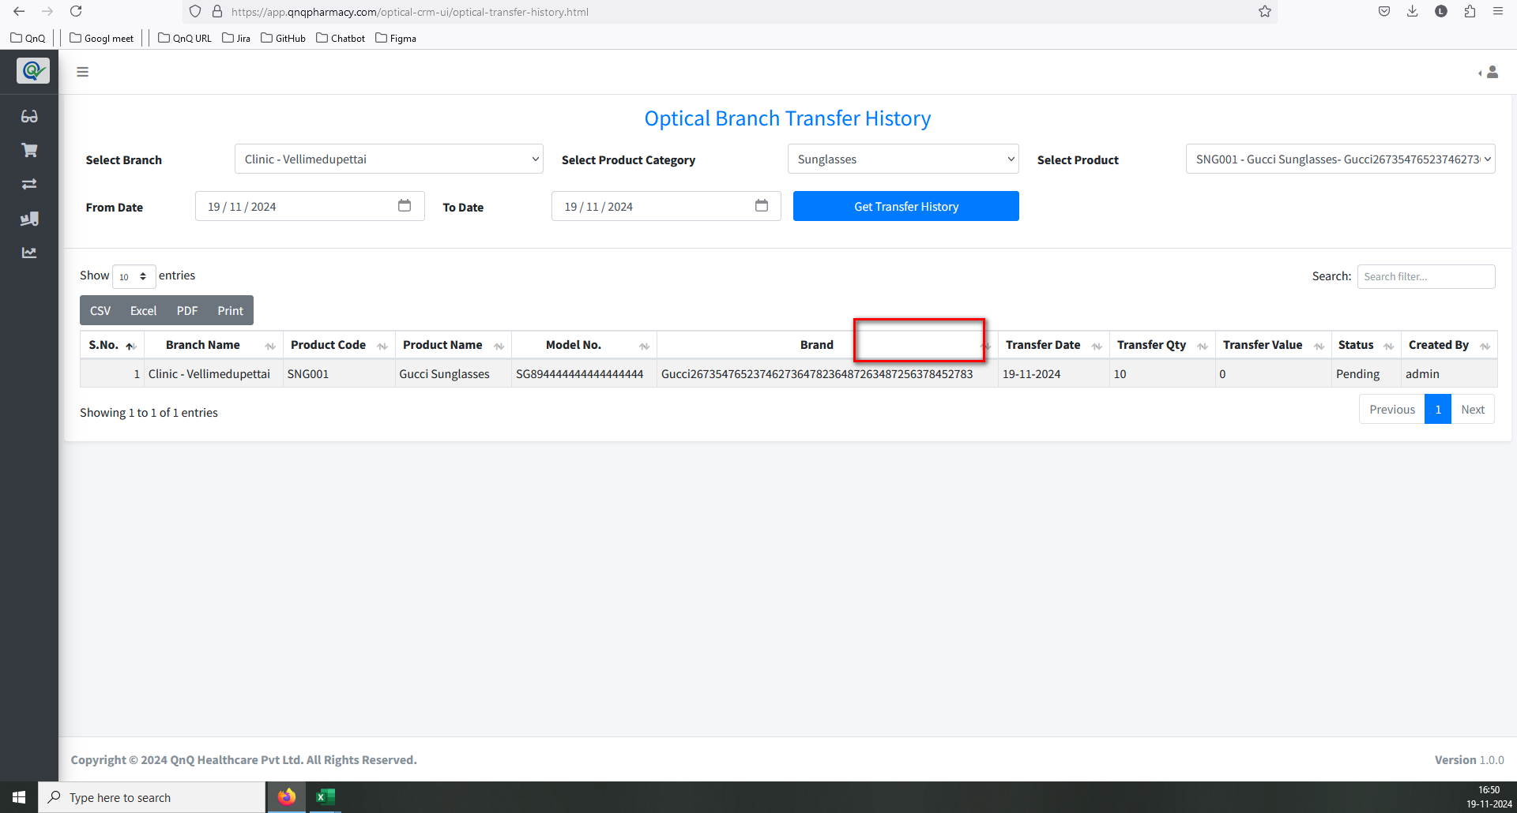//
10. Mismatch File name display in the download file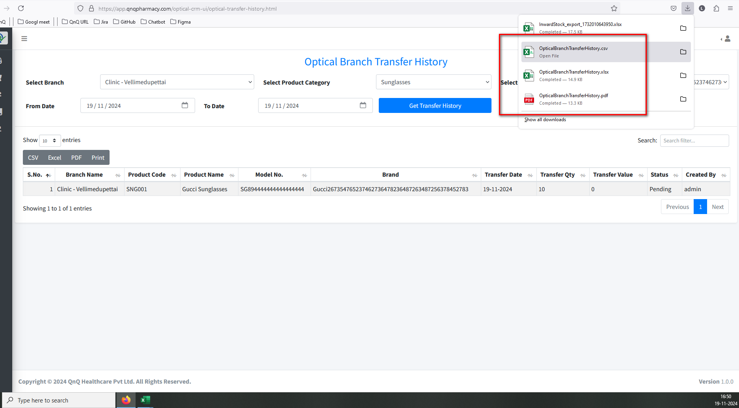 //
11. Download options are displayed even when no values are available in the list grid 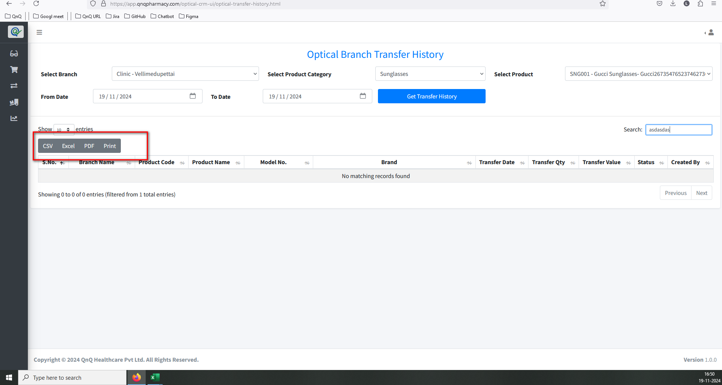//
12. The history grid displays values after clearing the selected filter 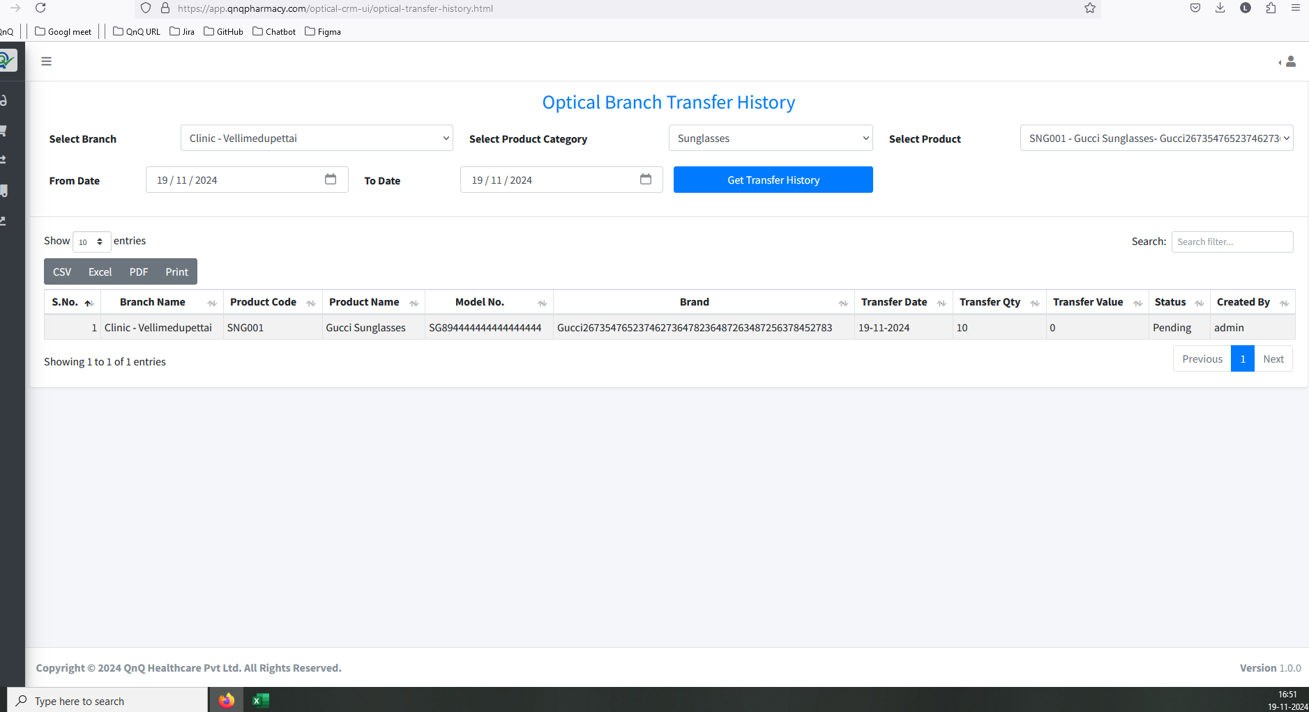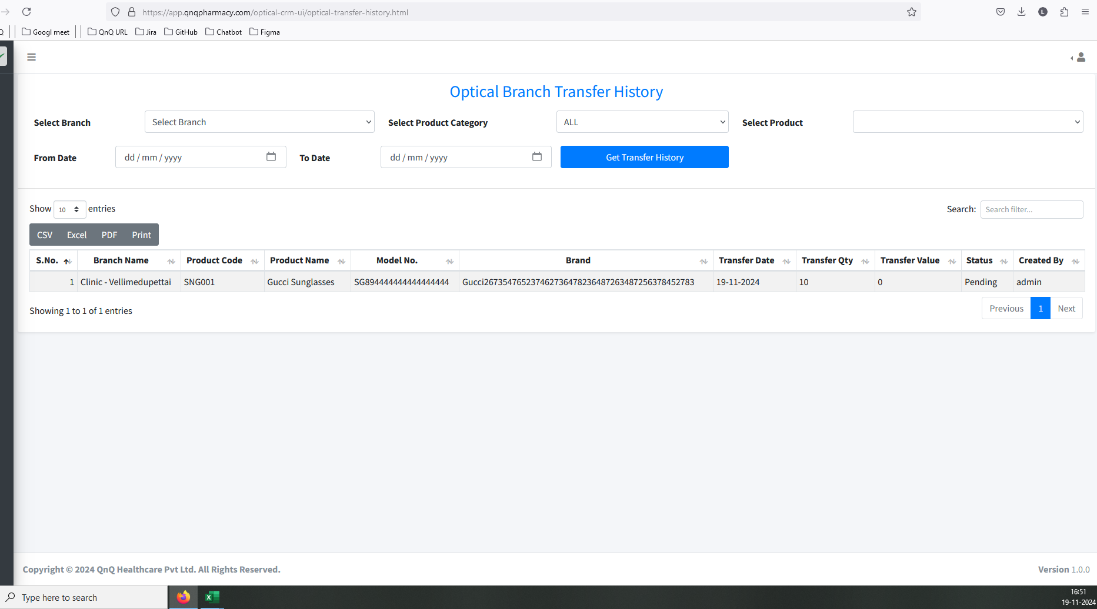//
13. Search filter and Pagination not display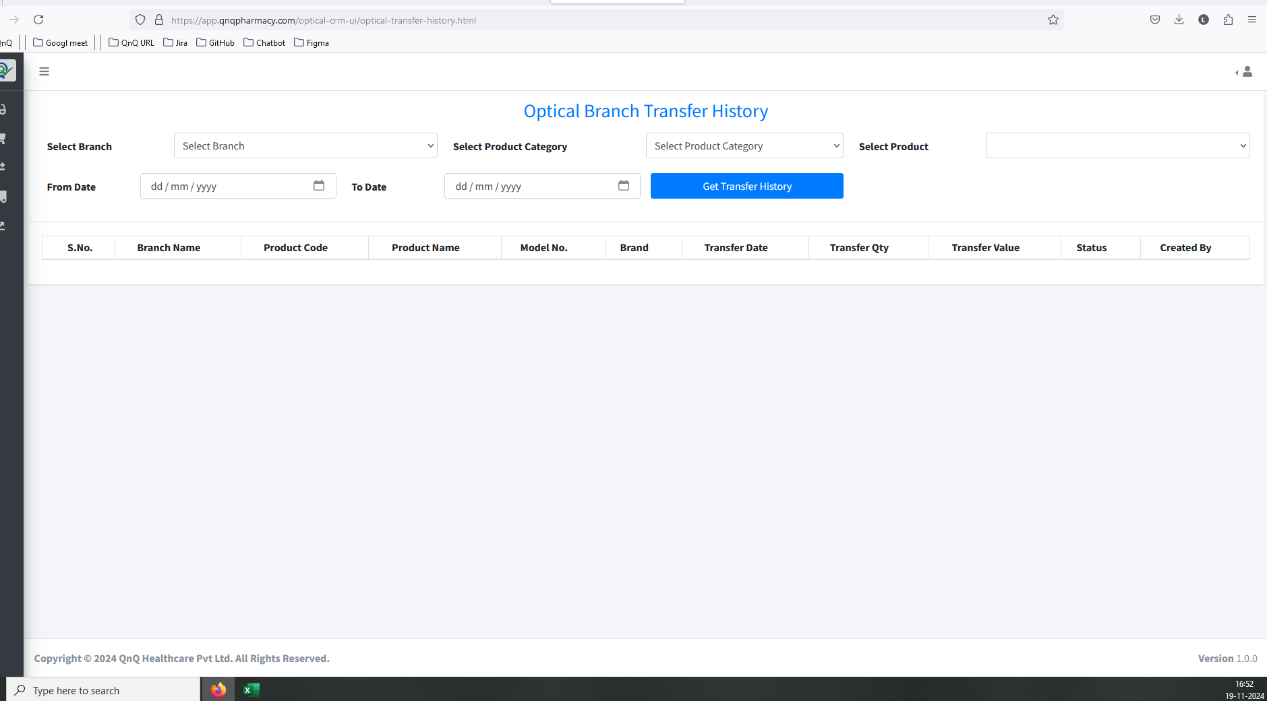 //
14. No record available message not display in list grid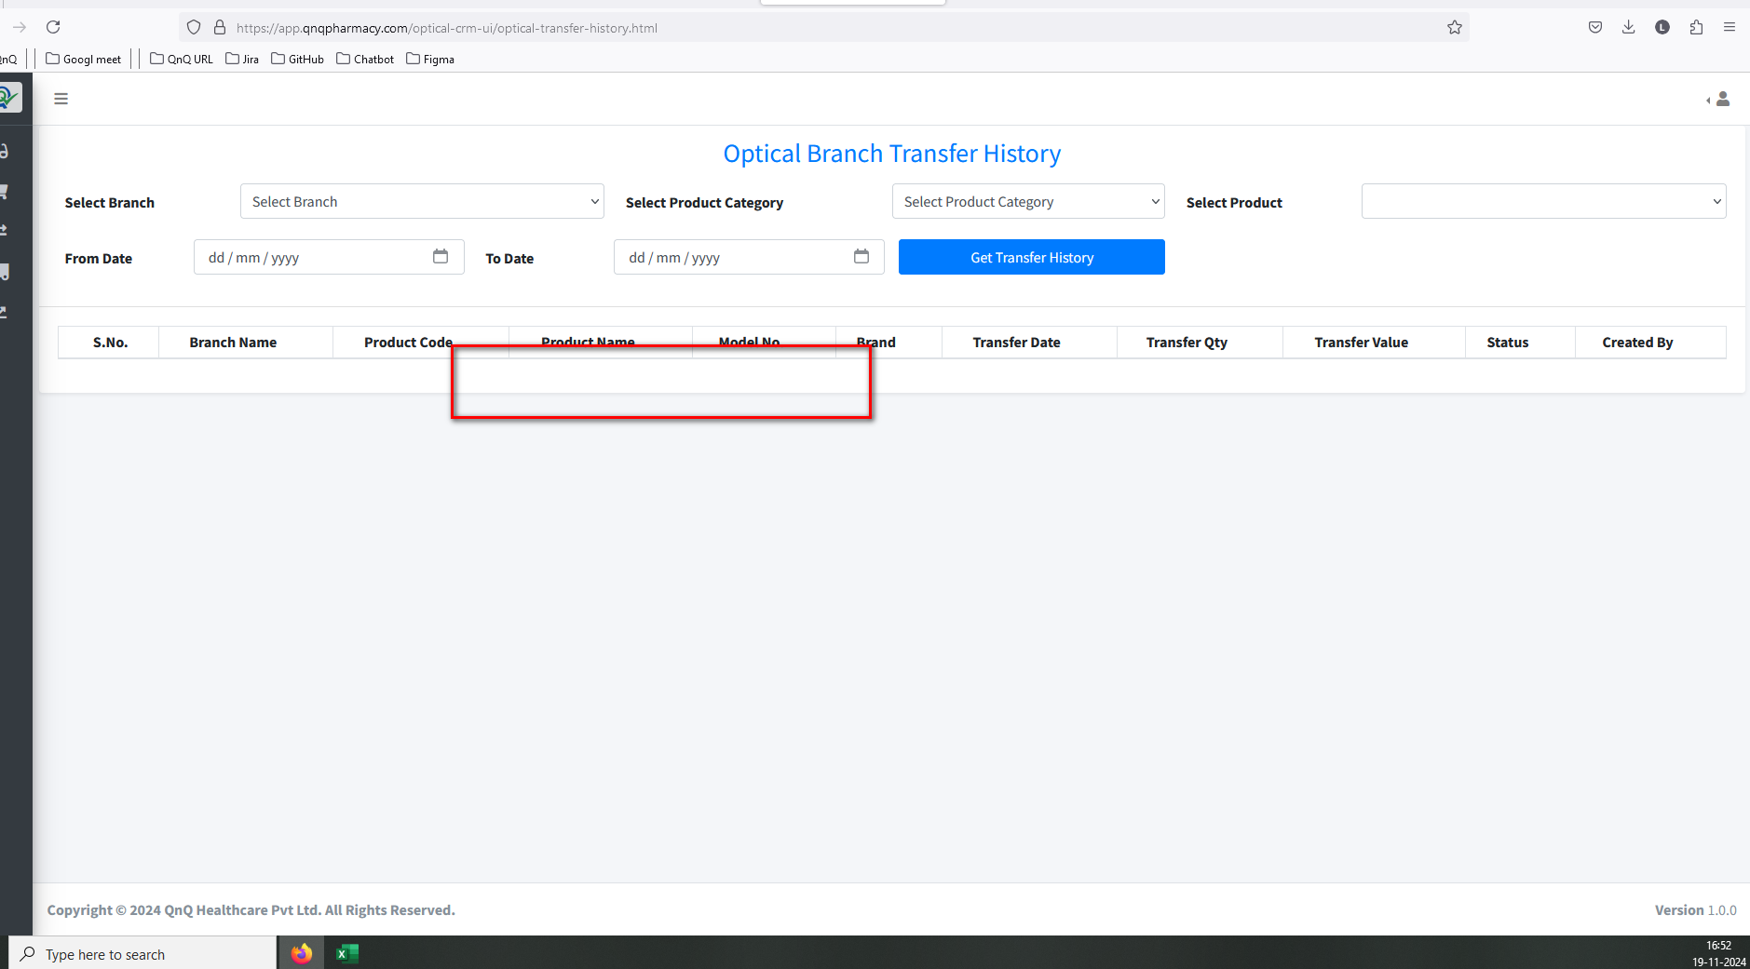 //
15. The navigation suggestion does not appear in the Rate History List grid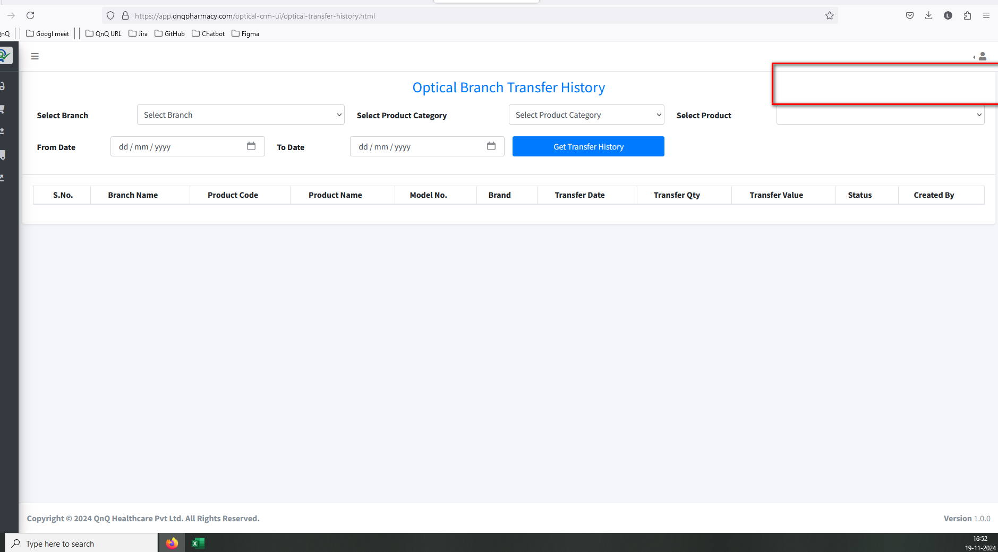 //
16. Excessive space is appearing between the label and the field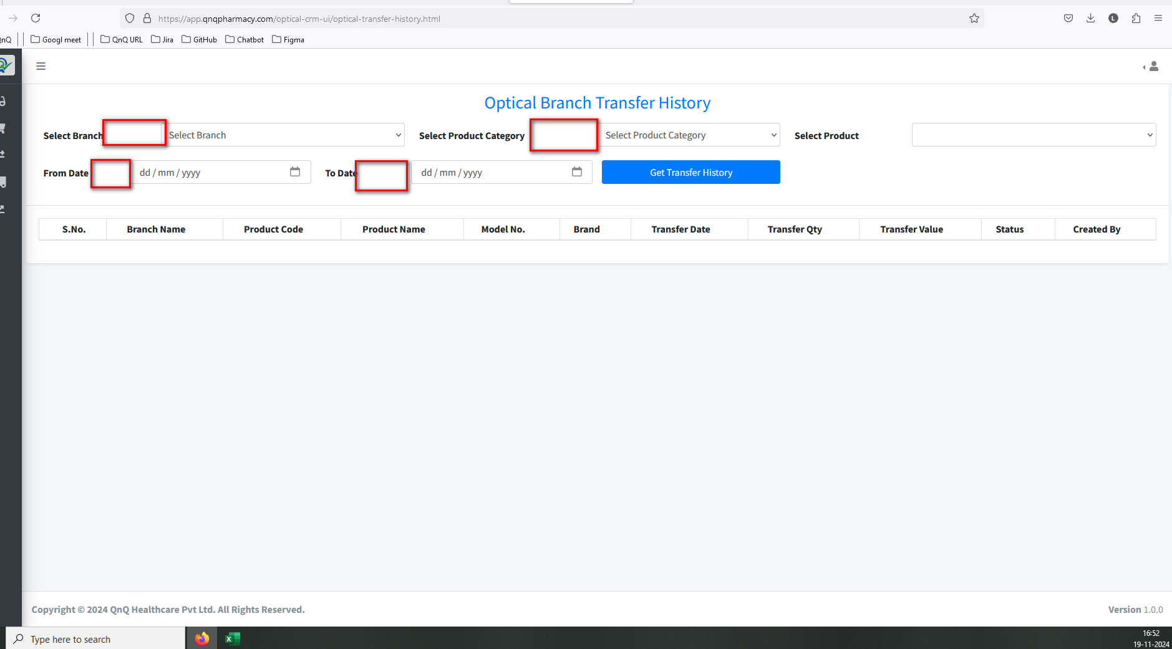//
17. Required error message display while click the Rate details button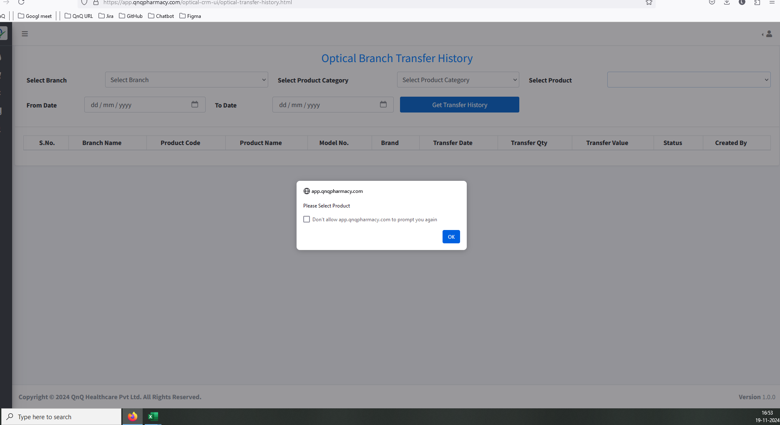//
18. The sheet name appears without spaces in CSV file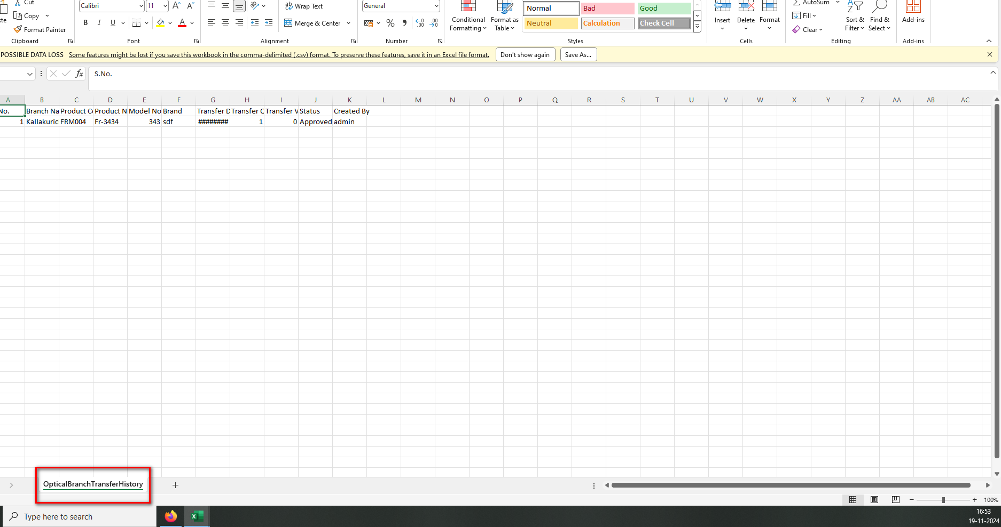 //
19. Document Title not display in CSV file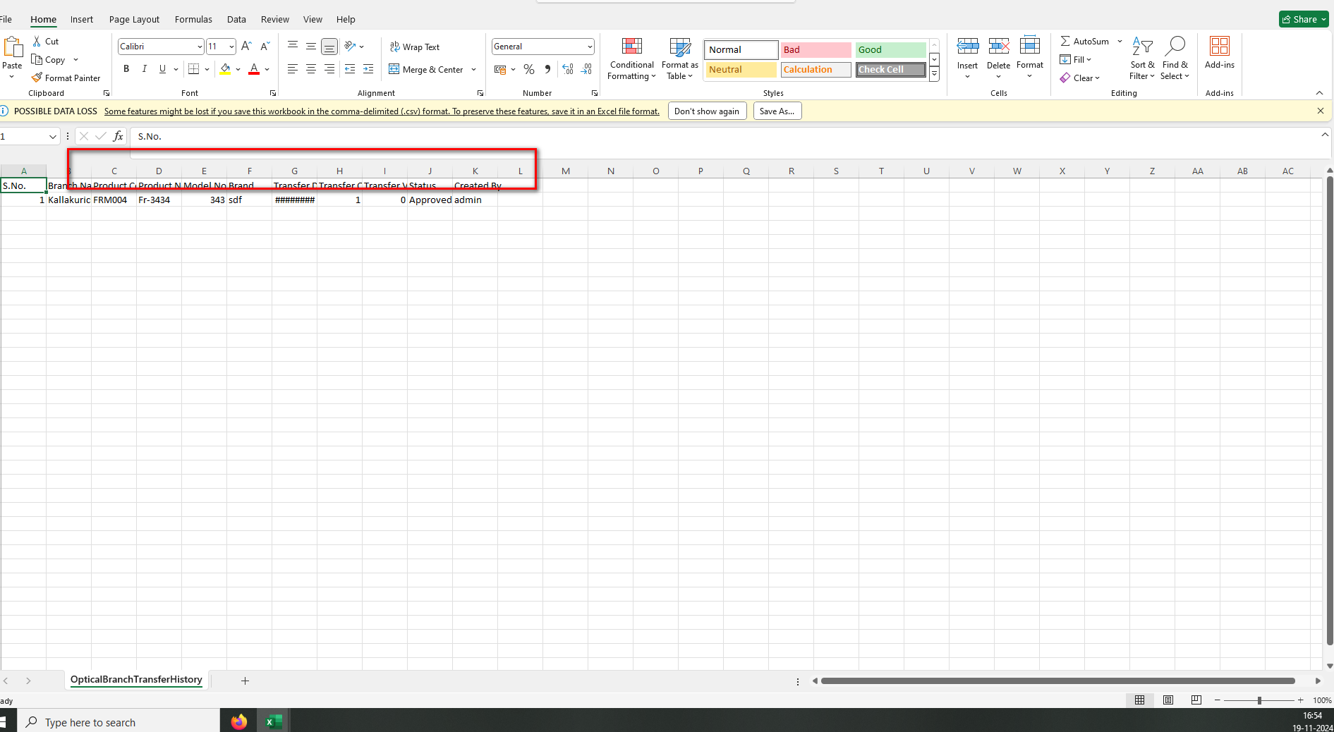 //
20. Sheet name not display in excel file 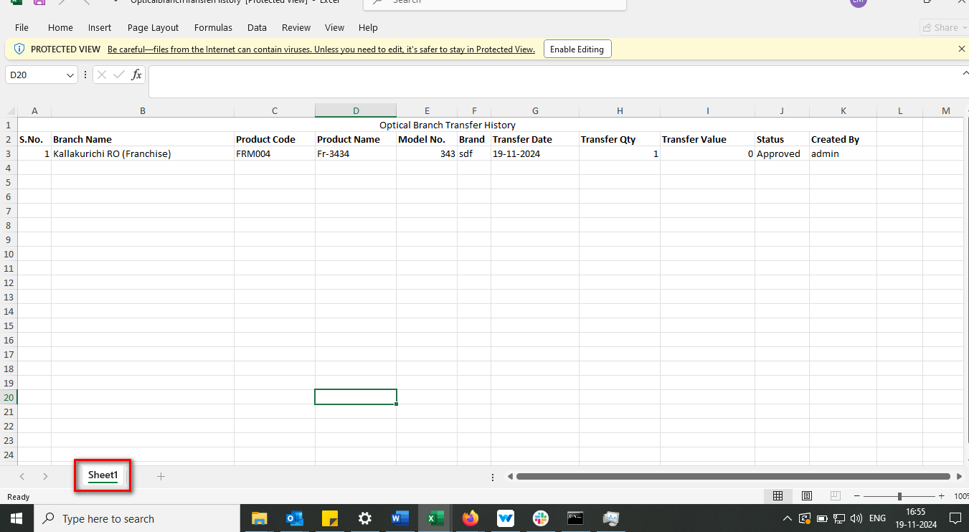//
21. Placeholder/Inner Text not display in Product Name field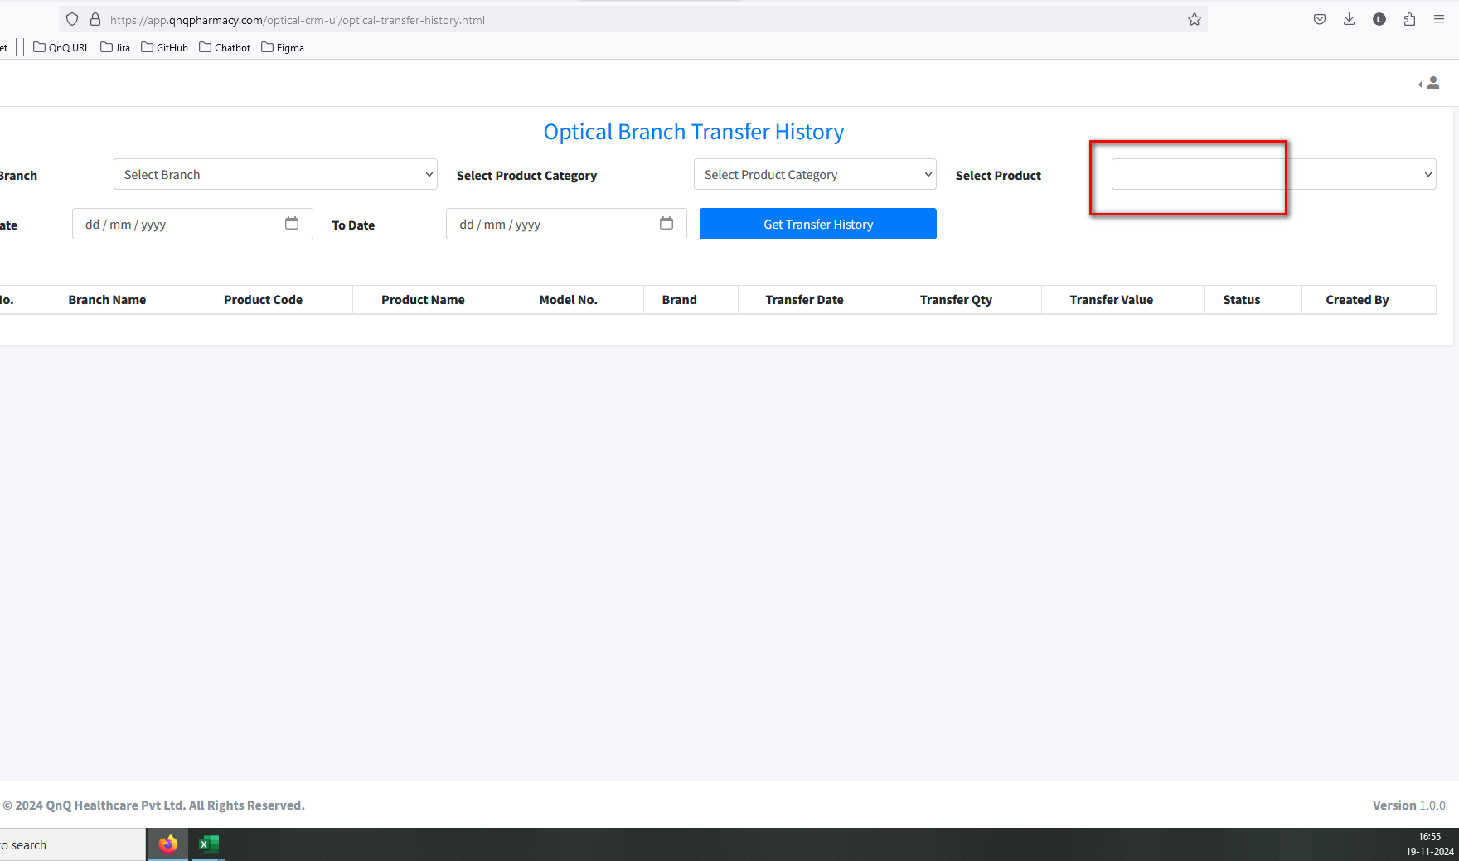//
22. First letter display as small letter in Showing records content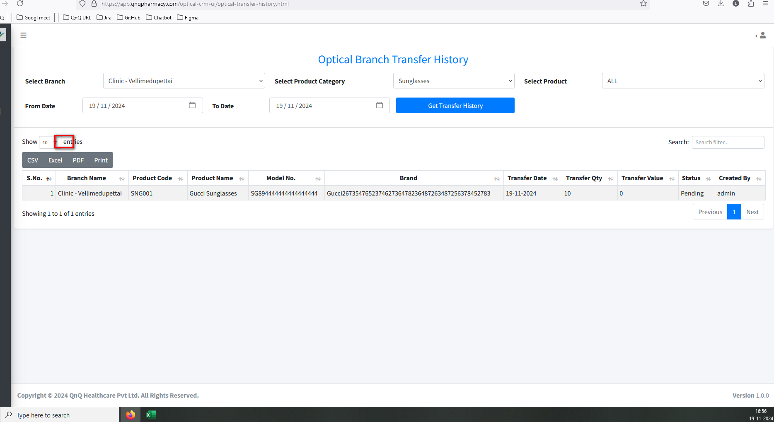//
23. Unwanted content display in all dropdown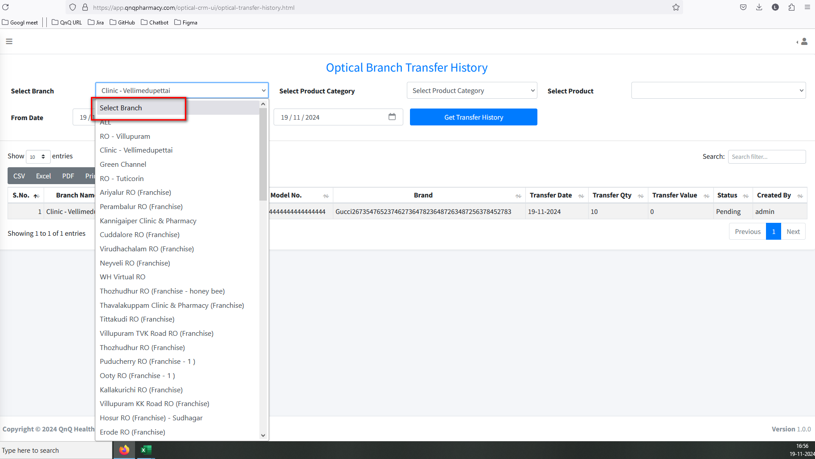 //
24. Unwanted Print button display in list grid 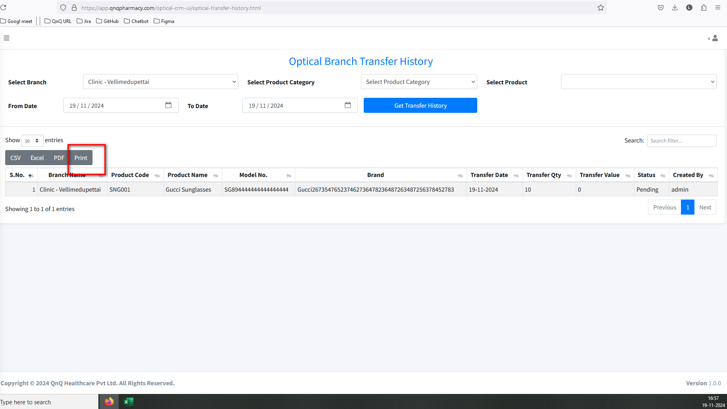//
25. First letter display as small letter in date field placeholder/inner text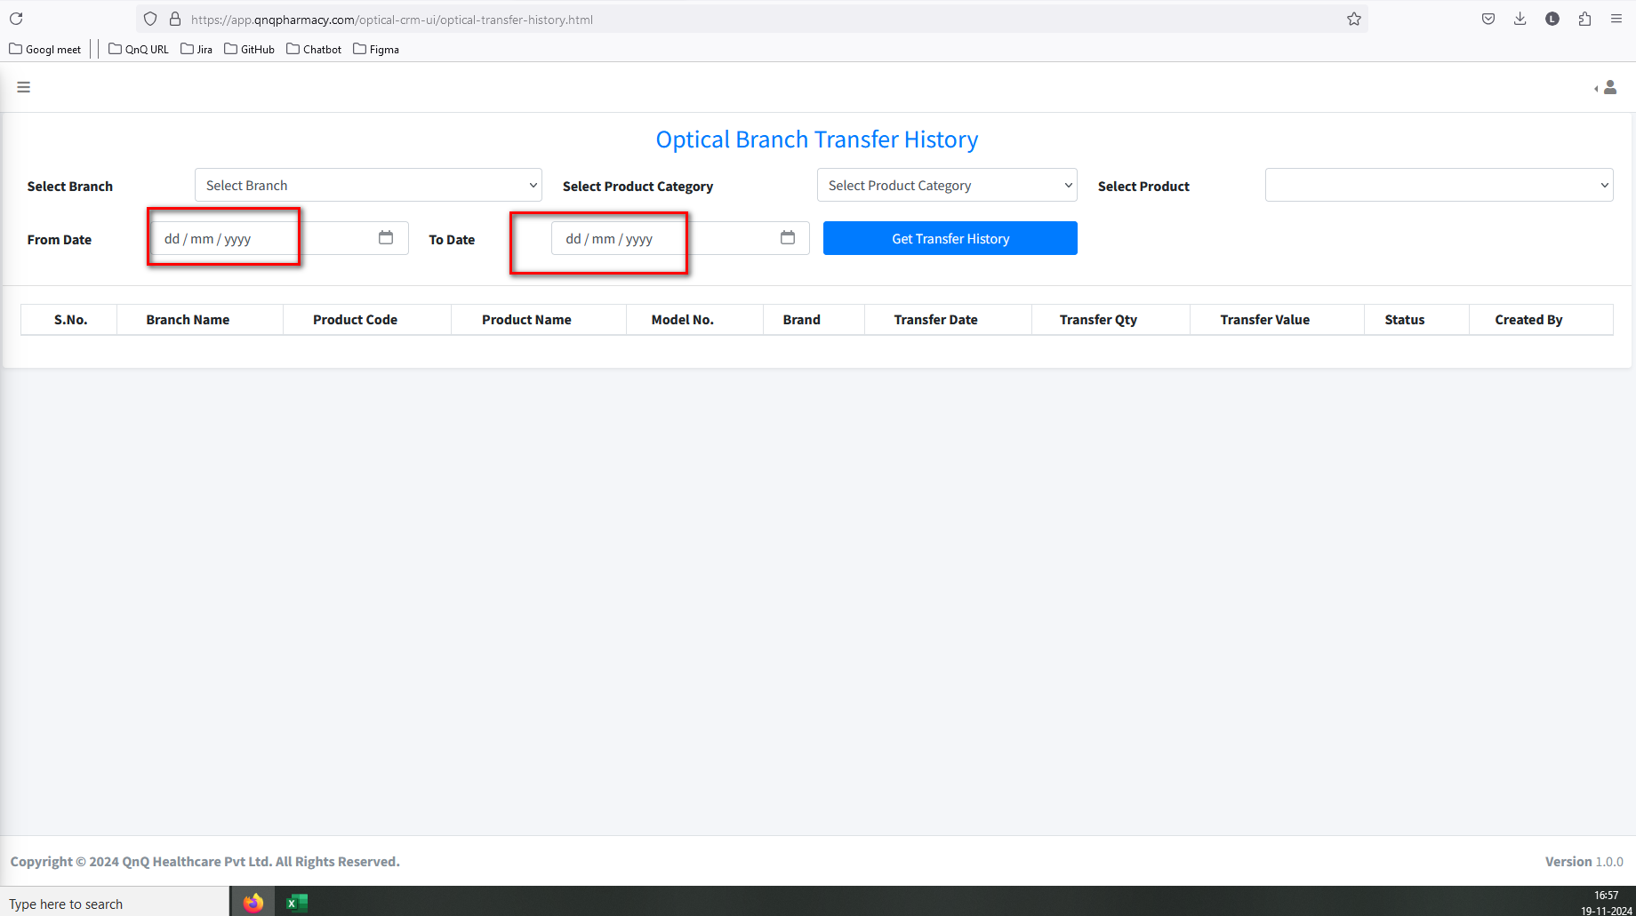//
26. Unwanted error message display while select the To date value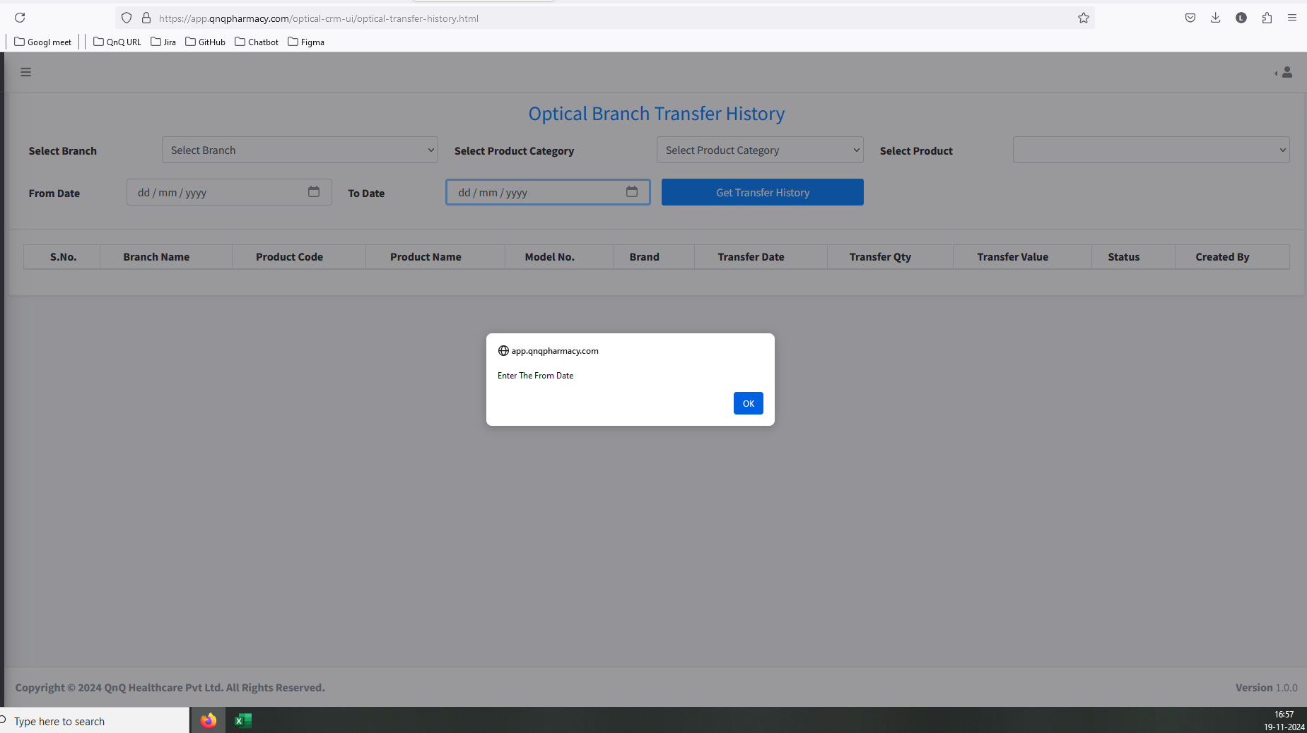//
27. The date field doesn't support copy and paste functionality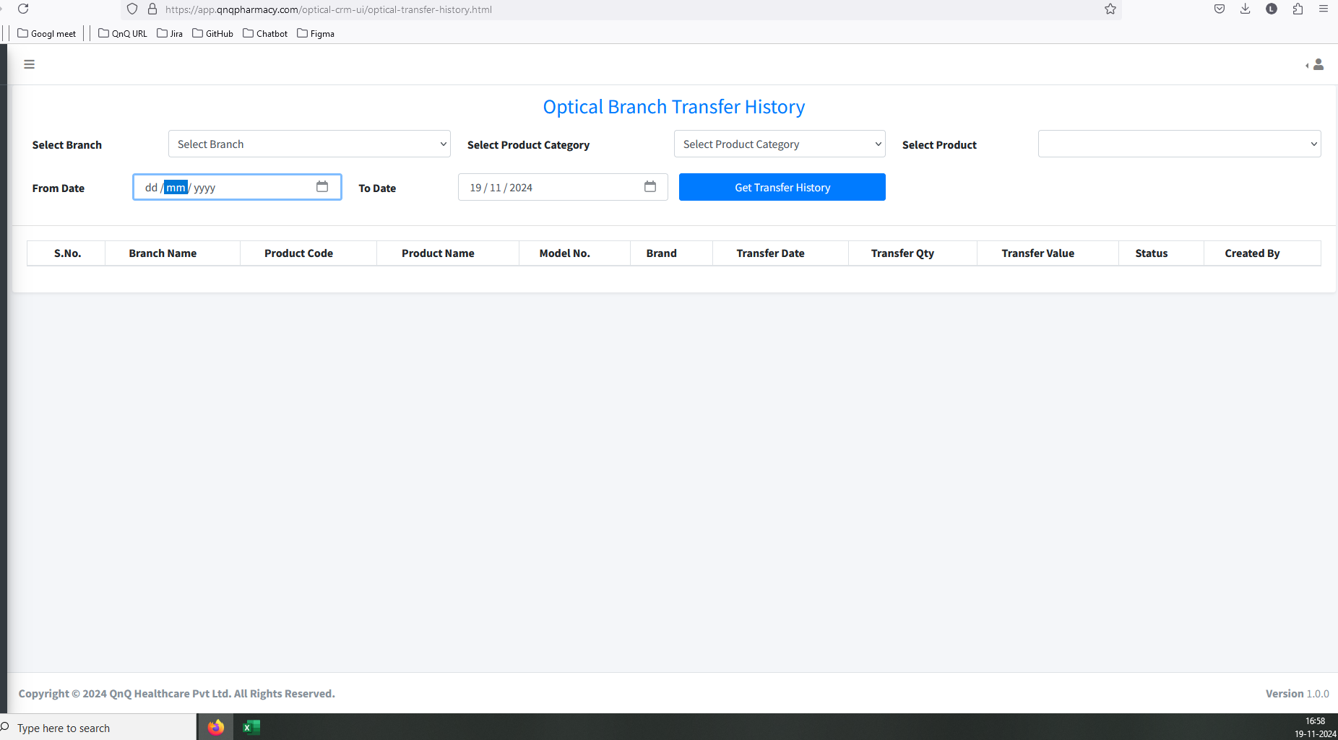//
28. Mismatch content display in pop up title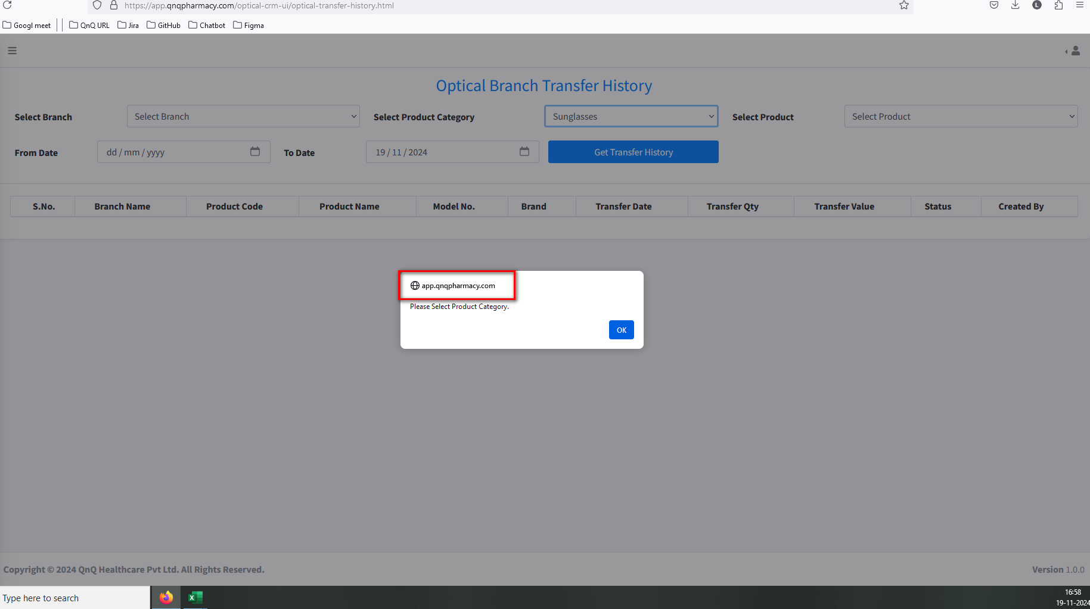//
29. Error message not display in Date field while give future date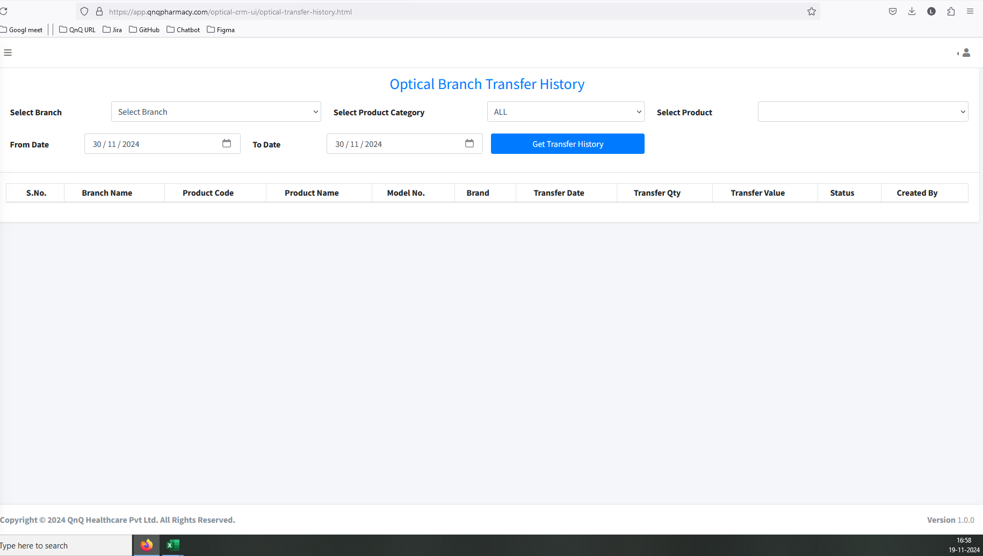//
30. Branch Transfer History not display record while update the record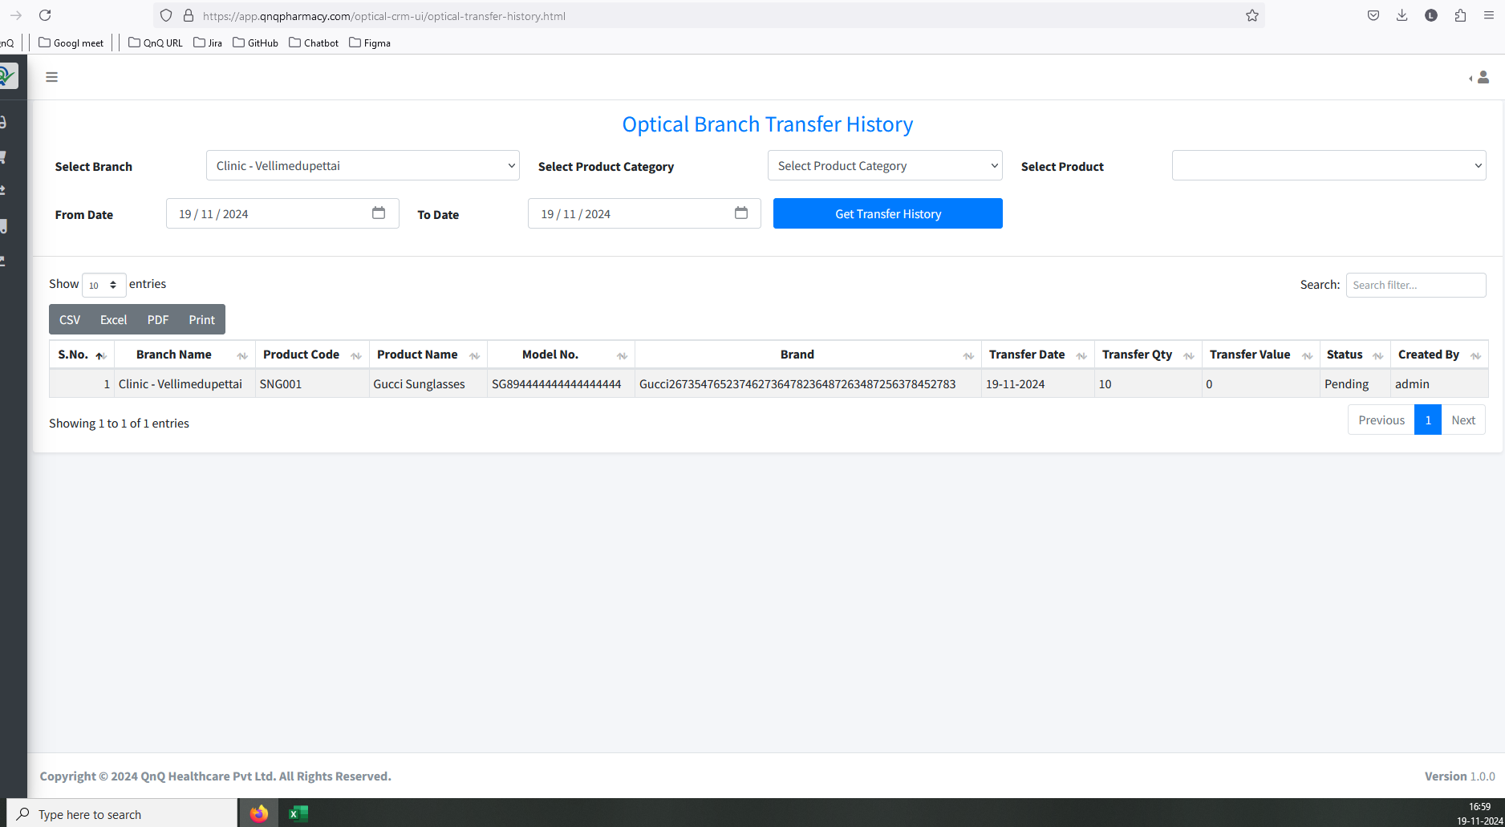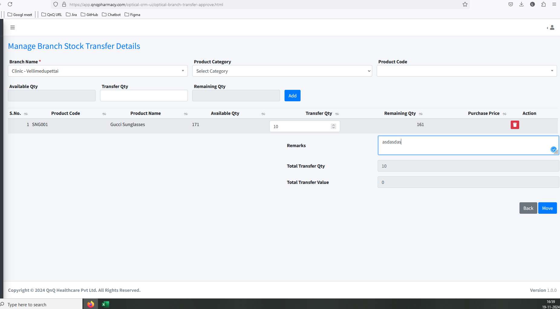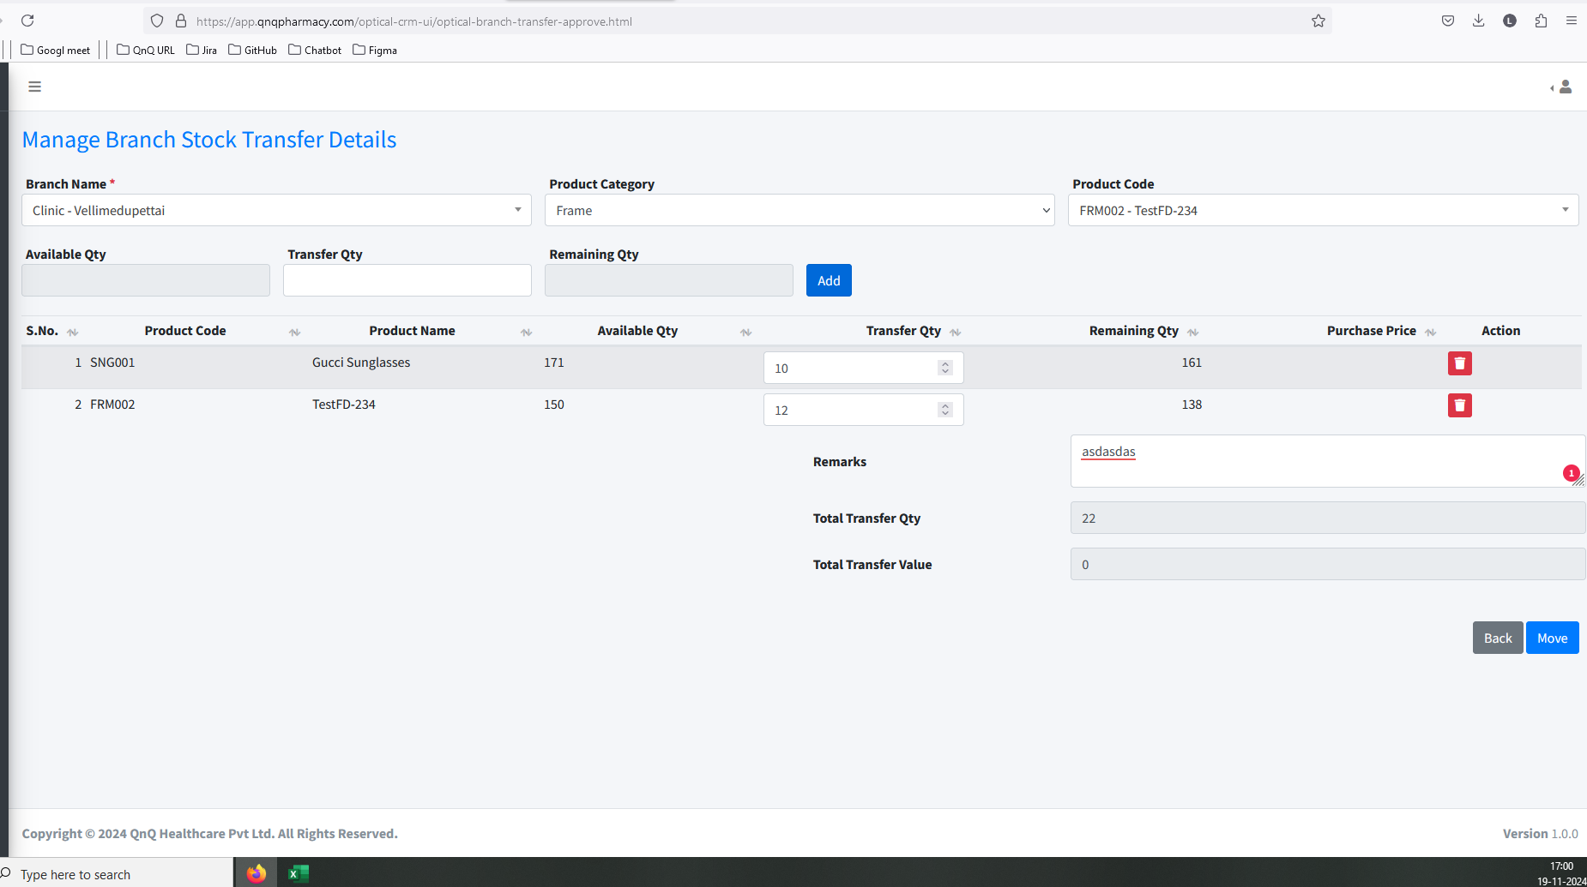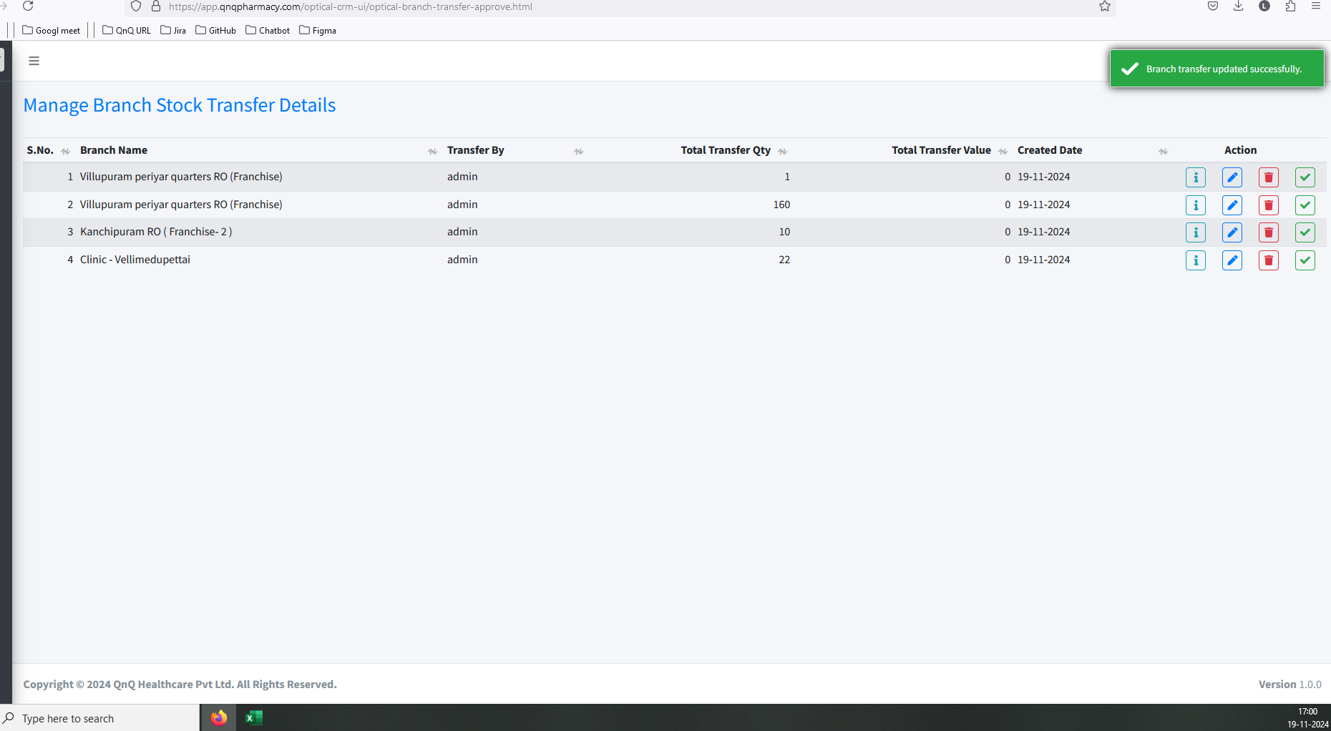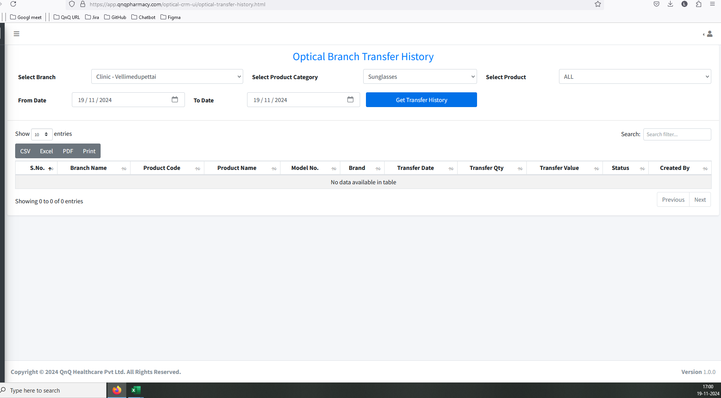//
31. Column value not display in list grid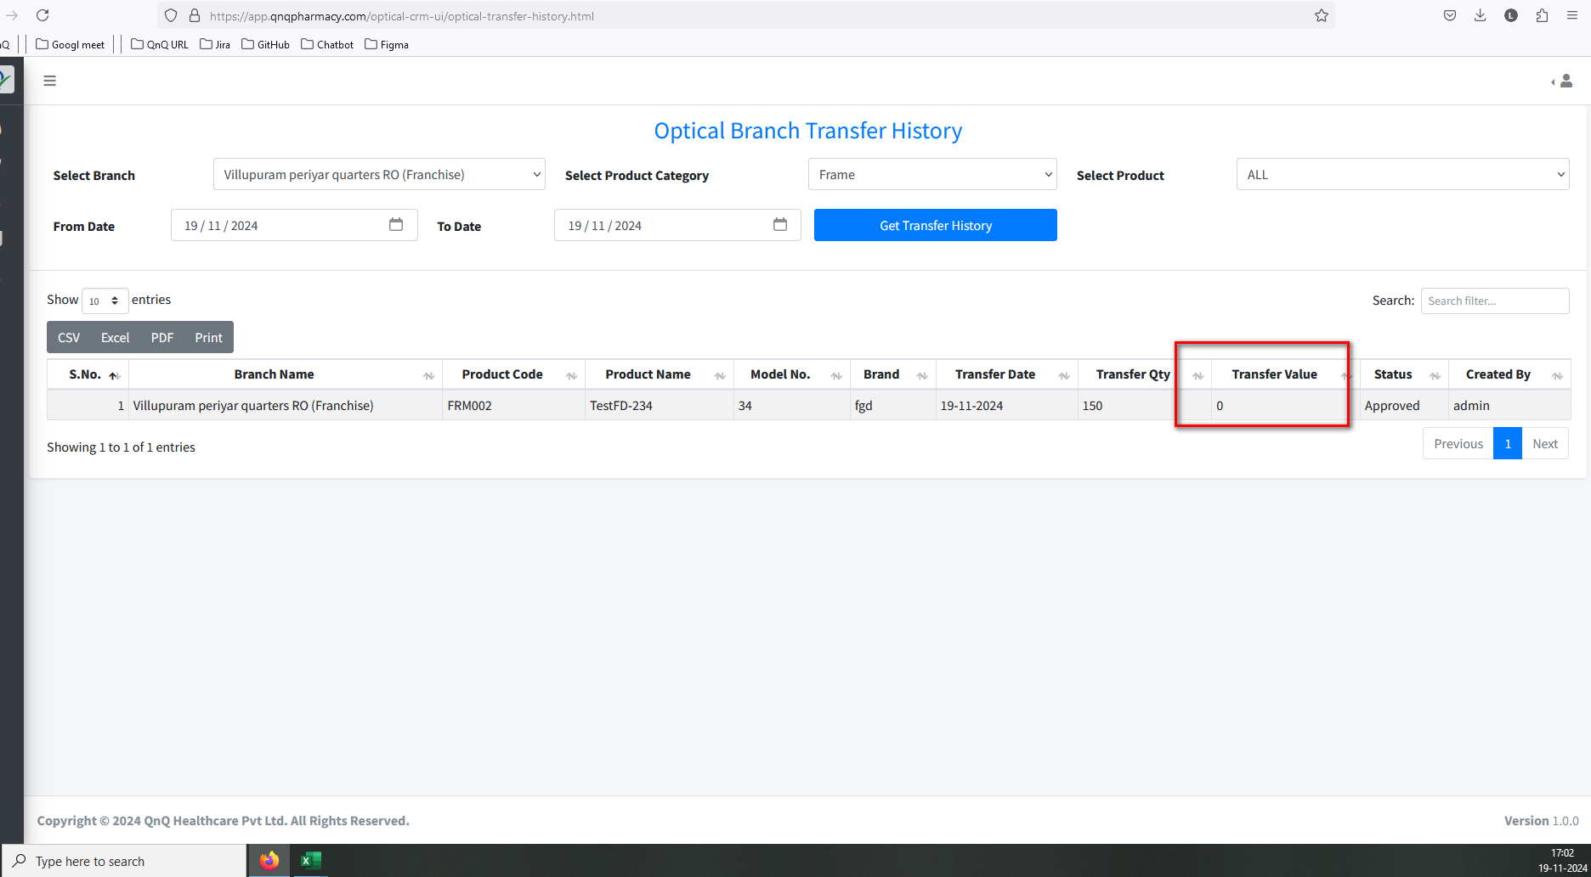//
32. Approved by column not display in list grid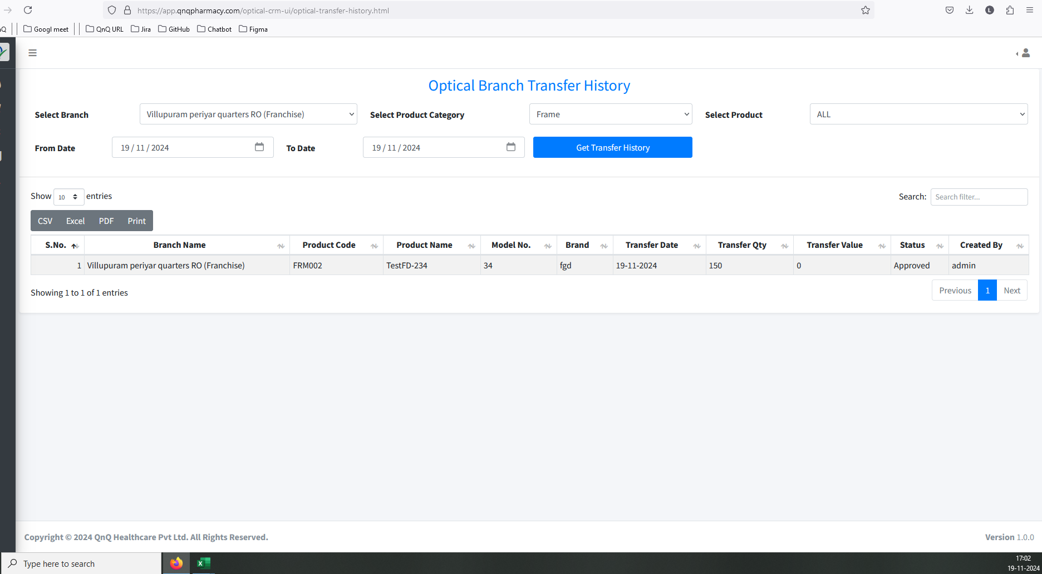//
33. Mismatch column name display in list grid